RESUME
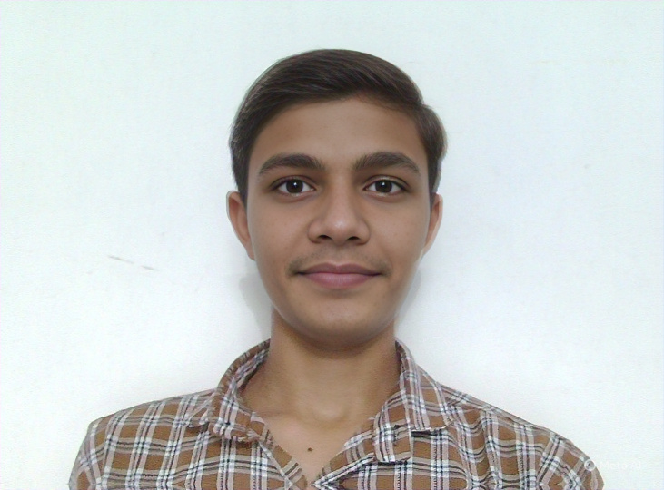
Personal Details
Name: [PAREKH VIVEKKUMAR A.]
Date of Birth: [04-09-2007]
Age: [Seventeen]
Phone: [+91-7041175669]
Email: [vivekparekh0409@gamil.com ]
LinkedIn: [linkedin.com/in/parekh-vivekkumar-gp-kheda-it-dte-03b3572b6]
Address: [1/C/498/Laxmi Chowk/Vivekanand Nagar /Hathijan/Ahmedabad/Pncode:-382445]
Languages Known: Gujrati,Hindi,Engalish
Domicile:
Nationality:

Career Objective
[Write a short and clear objective here, e.g., "To secure a position in the field of Mechanical Engineering where I can apply my skills and contribute to the organization."]

Academic Profile
Enrollment Number: [12-digit GTU Enrollment Number]
Institute: Government Polytechnic, Kheda
University: Gujarat Technological University (GTU)
Branch: [Branch Name, e.g., Mechanical Engineering]
Current Semester: [e.g., 5th Semester]
Expected Completion: [Month, Year, e.g., June 2026]
Current CGPA: [CGPA] / 10 (up to [nth] Semester)

Technical Skills
[List relevant tools, programming languages, and software]

Internships / Industrial Training
Company: [Name], Location: [City] – Duration: [Month Year – Month Year]
Title of the Internship Project:
Learning Outcomes: [Brief description]

Trainings
[Wadhwani Foundation/ Spoken Tutorial/ Finishing School/ Swayam-NPTEL MOOC/ IIT-Bomabay/ NASSCOM/SCOPE or any other employability booster training]

Projects
Project 1: [Project Title] – [Brief Description]
Project 2: [Project Title] – [Brief Description]
Final Year Project: [Project Title] – [Brief Description]

Co-curricular / Extra-curricular Activities
[Activity], [Role], [Year]

Achievements
[Award/Recognition], [Details], [Year]

References
[Name], [Designation], [Organization], [Email/Phone]

